CONTROLLING PC via VOICE

Project report submitted in partial fulfillment of the Requirements for the Award of the Degree of
BACHELOR OF TECHNOLOGY
In
COMPUTER SCIENCE AND ENGINEERING
By
MEGHANA KANDRU

Under the Guidance of
A.JITENDRA, M.Tech
Assistant Professor



DEPARTMENT OF COMPUTER SCIENCE AND ENGINEERING
V.R SIDDHARTHA ENGINEERING COLLEGE
Autonomous and Approved by AICTE
Affiliated to Jawaharlal Nehru Technological University, Kakinada

- INTRODUCTION

  - INTRODUCTION
[1]This document aims at defining the overall software requirements for “Voice Enabled Windows”. Efforts have made to define the requirements exhaustively &accurately. The final product will be having only features or functionalities mentioned in this document and assumption for any additional functionality or feature should not be made by any parties involved in developing and testing and implementation and using this product. [2]This document describes the capabilities that will be provided by the software application “Voice Enabled Windows”. By this application software we able to control computer system by the help of voice. The application will manage the information about voice to their respective operation.[4] This project basically deals with given voice command and their respective action taken in computer windows. If configured properly, speech recognition will provide the user a “hands-free” control over the computer. For example—if we want to open the note pad if say open the notepad then notepad would be opened and the we can edit in that note pad by the help of the voice.You will need to place a (Shortcut) to the speech recognition application withinthe Windows operating system (Startup) folder. This causes the application to launch when the computer is turned on.Speech technology is a very popular term right now. It can be divided into two categories: speech recognition and speech synthesis. They have both been popular research subjects for over four decades. Speech recognition is highly demanded and has many useful applications. The speed of typing and handwriting is usually one word per second, so speaking may be the fastest communication form with a computer.

1.2 PROBLEM STATEMENT

[3]This is a desktop application which means it has to be installed on any machine to get it in a working state. The application shall help you to control computer through voice.The software can be used by any user, there is not any specific requirement for an operating system but then it has to be at least Microsoft.It will provide the user a definite amount of "hands-free" control over the computer so that we can operate everything with speaking to the microphone.
It’s a fast mode of operating computer.This service is effectively used at peaceful place, because external sound may affect the working of the software.It’s one of the best methods for operating computer even an illiterate person can operate any computer by simply using his/her voice.By using this application we can save our time.

1.3 SCOPE AND OBJECTIVE

[5]The objective of this project is “Controlling PC via Voice “and providing an easy medium of operating computer.
Speech Recognition is a technology that allows the computer to identify and understand words spoken by a person using a microphone or telephone. The ultimate goal of the technology is to be able the basic utility software within a few seconds by just saying the name of that utility.

- LITERATURE SURVEY

2.1 Controlling Device through Speech Recognition System
Vishakha Karpe, Shilpa Kabadi, Asmita Mutgekar, Manisha Pokharkar
Speech technology is a very popular term right now. It can be divided into two categories: speech recognition and speech synthesis. They have both been popular research subjects for over four decades. Speech recognition is highly demanded and has many useful applications. The speed of typing and handwriting is usually one word per second, so speaking may be the fastest communication form with a computer. This research is concerned with speech recognition technology, which is part of speech and signal processing, as well as human computer interaction (HCI). Voice recognition is used to map a voice command with its corresponding action. This is brought about by converting speech to text. The program matches the input voice with the voice on which it is trained and maps it to the best possible result. The speech recognition engines are responsible for converting acoustical signals to digital signals, and then to text. The speech synthesizer engines are responsible for converting text to a spoken language. This process first breaks the words into phonemes, which are then transformed to a digital audio signal for playback. The applications with voice recognition can also be a very helpful tool for handicapped people who have difficulties with typing. The Sphinx-4 architecture has been designed for modularity; any module in the system can be smoothly exchanged for another without requiring any modification of the other modules.

2.2 Voice Command Based Computer Application Control
Abinayaa B., Arun D., Darshini B., Nataraj C

Speech processing is an efficient application area of digital signal processing. Speech recognition, Speaker recognition, voice command based applications, etc uses speech signals for their processing. In speech processing speaker recognition is an interesting research field and still there are number of problems unresolved. Speaker recognition is determined by the speaker identity. The speaker’s identity can be recognized by their voice, which must be familiar to humans and also to machines. This paper speech processing into two components, one is speaker identification and the second is speaker verification. Speaker identification includes training of voice and speaker verification includes testing of the acquired voice with the trained voice. Speech recognition research field has become more powerful nowadays. The interactive speech applications are becoming more popular now-a-days in the market. Speech recognition systems allows us to input voice to an application rather than getting input from mouse, keyboard or any other input forms. This paper establishes speech processing in two forms, speech identification and speech verification

2.3 EXISTING SYSTEM

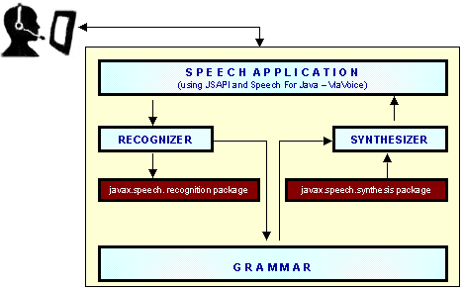
Fig 2.1: Process of Speech Recognition
Activating a feature within the speech recognition software application known as (Startup/Shutdown) has the speech recognition program prepared for immediate speech recognition.At this point, the user only needs to say the command (Wake Up). Launching a third party application such as Microsoft Word 2000, the user only need say (Start Microsoft Word). If the user wishes to launch their Internet browser, they simply say the command (Start Internet Explorer).Paralysis due to cervical spinal cord injury. The user will need assistance placing the headset/microphone on their head. Positioning of the microphone is critical for good recognition. Instructorless details how to control your computer with spells... err, how to set up voice recognition commands forcommon actions using a Windows application called Voice Activated Command.
2.3.1 Speech Recognition:

Speech recognition is the process of converting spoken language to written text or some similar form. The basic characteristics of a speech recognizer supporting the Java Speech API are:
- It is mono-lingual
- It supports a single specified language.
- It processes a single input audio stream.
- It can optionally adapt to the voice of its users.
- Its grammars can be dynamically updated.
- It has a small, defined set of application-controllable properties.
Fig 2.2: Components of Speech Recognition System

The major steps of a typical speech recognizer are: Grammar design: recognition grammars define the words that may be spoken by a user and the patterns in which they may be spoken. A grammar must be created and activated for a recognizer to know what it should listen for in incoming audio. Grammars are described below in more detail. Signal processing: analyze the spectrum (frequency) characteristics of the incoming audio.

Phoneme recognition: compare the spectrum patterns to the patterns of the phonemes of the language being recognized. (A brief description of Java Speech Application Programming Interface 14 phonemes is provided in the “Speech Synthesis” section in the discussion of text-to-phoneme conversion).
Word recognition: compare the sequence of likely phonemes against the words and patterns of words specified by the active grammars. Result generation: provide the application with information about the words the recognizer has detected in the incoming audio.

The result information is always provided once recognition of a single utterance (often a sentence) is complete, but may also be provided during the recognition process. The result always indicates the recognizer’s best guess of what a user said, but may also indicate alternative guesses. Most of the processes of a speech recognizer are automatic and are not controlled by the application developer. For instance, microphone placement, background noise, sound card quality, system training, CPU power and speaker accent all affect recognition performance but are beyond an application’s control. The primary way in which an application controls the activity of a recognizer is through control of its grammars.
2.3.2 Speech Synthesis

A speech synthesizer converts written text into spoken language. Speech synthesis is also referred to as text-to-speech (TTS) conversion. The major steps in producing speech from text are as follows:
Structure analysis: process the input text to determine where paragraphs, sentences and other structures start and end. For most languages, punctuation and formatting data are used in this stage. Text pre-processing: analyze the input text for special constructs of the Java Speech Application Programming Interface 10 language. In English, special treatment is required for abbreviations, acronyms, dates, times, numbers, currency amounts, email addresses and many other forms. Other languages need special processing for these forms and most languages have other specialized requirements. The result of these first two steps is a spoken form of the written text. The following are examples of the difference between written and spoken text.The remaining steps convert the spoken text to speech are:
Text-to-phoneme conversion: convert each word to phonemes. A phoneme is a basic unit of sound in a language. US English has around 45 phonemes including the consonant and vowel sounds. For example, “times” is spoken as four phonemes “t ay m s”. Different languages have different sets of sounds (different phonemes). For example, Japanese has fewer phonemes including sounds not found in English, such as “ts” in “tsunami”.
Prosody analysis: process the sentence structure, words and phonemes to determine appropriate prosody for the sentence. Prosody includes many of the features of speech other than the sounds of the words being spoken.
This includes the pitch (or melody), the timing (or rhythm), the pausing, the speaking rate, the emphasis on words and many other features. Correct prosody is important for making speech sound right and for correctly conveying the meaning of a sentence.
Waveform production: finally, the phonemes and prosody information are used to produce the audio waveform for each sentence. There are many ways in which the speech can be produced from the phoneme and prosody information. Most current systems do it in one of two ways: concatenation of chunks of recorded human speech, or formant synthesis using signal processing techniques based on knowledge of how phonemes sound and how prosody affects those phonemes. The details of waveform generation are not typically important to application developers.

2.3.3 Working of the Project and Speech Engine:

1. In first step speech is converted into text. There are some steps shown in fig. firstly though voice input waveform is generated. Using these waveforms phonemes is generated. Using these phonemes words are selected. And at last we get the text. This text are now stored in a storage system.
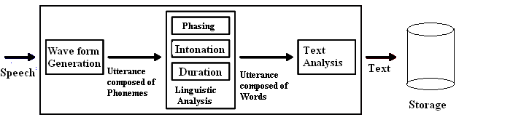
Fig 2.3: Process of Speech Synthesis

2. In second step the stored text is matched with already stored words. If the text is matched the query executes and finally we get the output.

Text

Result
Execute
Command
Related Result Show

Text

Fig 2.4: Processing of text to result

2.3.4 Limitations:
- Recognition in a speech application is supported by a grammar file for each collection. While there are a number of other settings related to timing and confidence level, a grammar file is what the speech engine compares to the caller’s utterance in order to determine a match.
- Typically, problems arise not when the speech recognition engine doesn’t recognize what the caller says, but rather when the caller says something that the grammar file did not contain or could not match to an entry in the file.
- The system is doing its best to confirm what the caller has spoken based on what the system knows.
- Unlike humans, ASR software always listens. Utterances callers likely don’t intend the system to recognize are often included in what the system hears.
- An example might be a chuckle or clearing of the throat. Busy callers carrying on multiple conversations while interacting with a speech application often don’t realize that the system is listening to both conversations. Poor caller behavior is very difficult to overcome.

    - APPLICATIONS:
1.Desktop
Natural language commands can provide improvements in efficiency but are increasingly being used in desktop environments to enhance usability. For many users it’s easier and more natural to produce spoken commands than to remember
the location of functions in menus and dialog boxes. Speech technology is unlikely to make existing user interfaces redundant any time soon, but spoken commands provide an elegant complement to existing interfaces.

2.Telephony Systems

Systems are already available for telephone access to email, calendars and other computing facilities that have previously been available only on the desktop or with special equipment. Such systems allow convenient computer access by telephones in hotels, airports and airplanes.

- SOFTWARE REQUIREMENT ANALYSIS

  - FUNCTIONAL REQUIREMENTS
To use the Java Speech API, a user must have certain minimum software and hardware available. The following is a broad sample of requirements. The individual requirements of speech synthesizers and speech recognizers can vary greatly and users should check product requirements closely.
1. Speech software: A JSAPI-compliant speech recognizer or synthesizers required.
2. System requirements: Most desktop speech recognizers and some speech Synthesizers require relatively powerful computers to run effectively. Check the minimum and recommended requirements for CPU, memory and disk space when purchasing a speech product.
3. Audio Hardware: Speech synthesizers require audio output. Speech recognizers require audio input. Most desktop and laptop computers now sold have satisfactory audio support. Most dictation systems perform better with good quality sound cards.
4. Microphone: Desktop speech recognition systems get audio input through a microphone. Some recognizers, especially dictation systems, are sensitive to the microphone and most recognition products recommend particular microphones. Headset microphones usually provide best performance, especially in noisy environments. Table-top microphones can be used in
some environments for some applications.

  - NON FUNCTIONAL REQUIREMENTS

1. Functionality: The main purpose of this project is to remind the user with voice alert about an event. This application let the user not to miss any event.
2. Usability:Android's default user interface is based on direct manipulation, using touch inputs, that loosely correspond to real-world actions, like swiping, tapping, pinching, and reverse pinching to manipulate on-screen objects, and a virtual keyboard.
3. Response time: The response to user input is designed to be immediate and provides a fluid touch interface, often using the vibration capabilities of the device to provide haptic feedback to the user.
4. Feasibility: In implementing the system, only small investment is sufficient. There is no maintenance cost. The existing resources are sufficient for developing Voice reminder application and there is no economic constraint.
5. Availability: The application is available to the user all the time. It also doesn’t require internet access to store the database or to give the notification.

4.SOFTWARE DESIGN

Data Flow Diagram:

After observing the present system, the first step in structured system analysis is to draw a data flow diagram. Graphical description of a system’s data and how the process transforms the data is known as data flow diagram (DFD). The DFD is a way of expressing system requirements in a graphical form. A DFD also known as a “bubble chart”, has the purpose of clarifying system requirements and identifying major transformations that will become programs in system design. A DFD consist of a series of bubbles joined by lines.

Level 0

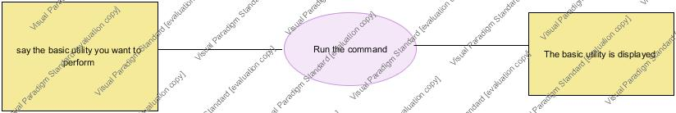
Fig 4.1: Data Flow Diagram
Level 1:
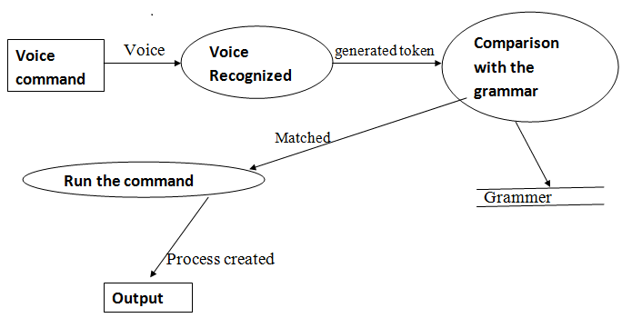
Fig 4.2: Data Flow Diagram of voice command

UML DIAGRAMS:
Usecase Diagram:

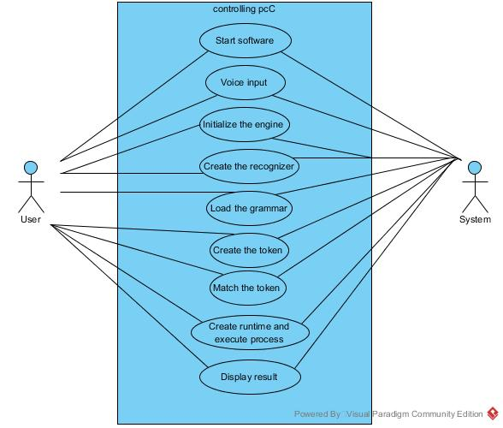
Fig 4.3: Usecase diagram of user
Class Diagram:
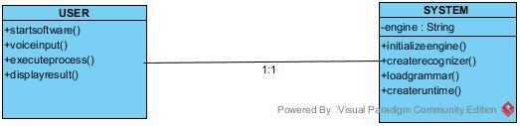

Fig 4.4:Class Diagram of user

Sequence Diagram:

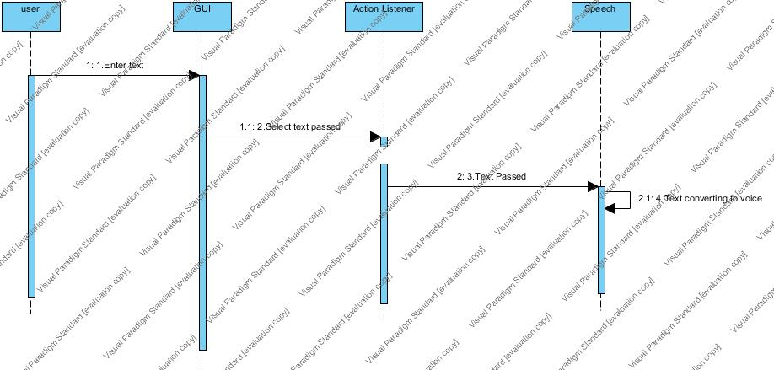

Fig 4.5: Sequence diagram

Collaboration Diagram:

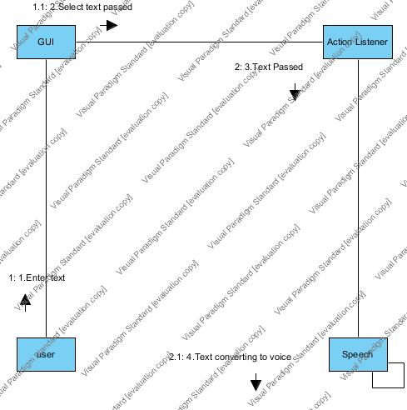
Fig 4.6: Collaboration diagram

Activity Diagram:
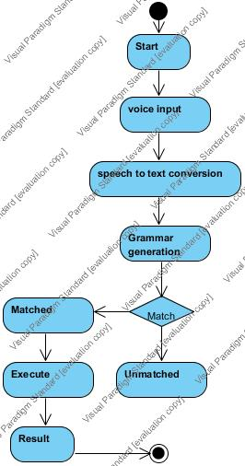
Fig 4.7: Activity Diagram
5.PROPOSED SYSTEM

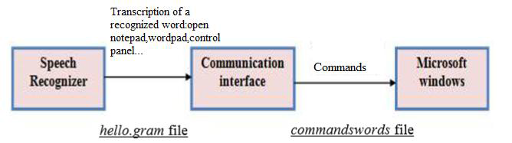
Fig 5.1: Components of Speech Recognition System
Architecture of the system that shown in figure includes certain components those are important for its formulation. It explains more details about how the system works? Or what the most requirement that must be available to the system in order to operate.
A. User: The voice command input given to the system by the user through microphone. Desktop speech recognition systems get audio input through a microphone. It must be one of the commands displayed on the screen.
B. Recognizer: A speech recognizer is a speech engine that converts speech to text. The basic functionality provided by a Recognizer includes grammar management and the introduction of results when a user says things that match active grammars. The Recognizer interface extends the Engine interface to provide this functionality. The major steps of a typical speech recognizer are as follows:
- Grammar design: Defines the words that may be spoken by a user and the patterns in which they may be spoken.
- Signal processing: Analyzes the spectrum (the frequency) characteristics of the incoming audio.
- Phoneme recognition: Compares the spectrum patterns to the patterns of the phonemes of the language being recognized.
- Word recognition: Compares the sequence of likely phonemes against the words and patterns of words specified by the active grammars.
- Result generation: Provides the application with information about the words the recognizer has detected in the incoming audio.
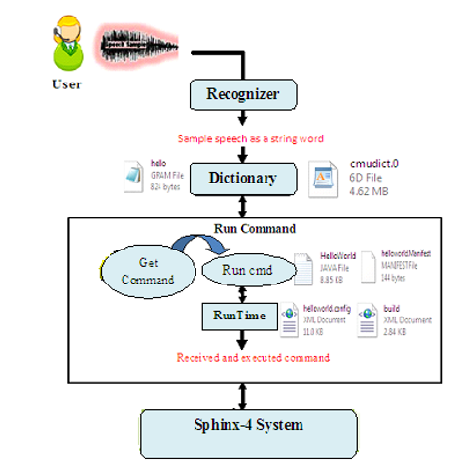
Fig 5.2: Architecture of Speech Recognition System.

C. Dictionary: Dictionary file (cmudict.6D or .dict extension) is a list of words with a sequence of phones. Responsible for determining how a word is pronounced. According to grammar (hello.gram), phonetic representation and Dictionary, the system returns an n-best list (i.e.:a word plus a confidence score). Dictionary means the mapping table of phonetic representation and word, for example “thu, thee” is mapping to “the”.
D. Run Command :This component received speech sample after convert it to words as a string from recognizer.
1) HelloWorld.java: this is very important component, it is the heart of the structure because in this component can get the final result about the work of the system.
2) getCommand: This method received word as command and send it to runCmd.
3) runCmd: this method received command as a string from getCommand method and executed it by call the both component runtime and process. Later on command is executed at runtime. The files helloworld.config, helloworld.manifest, build.xml are supporting files at runtime.
E. Sphinx-4 system: Consist of decoder, front end, knowledge base, grammar file (hello), and this application. Sphinx-4 having ability to dynamically load and configure modules at run time, yielding a flexible and pluggable system.

6. CODING

Code For Engine:

package Engine;

import Compare.GamesMatch;
import Compare.Match;
import Compare.OfficeDocument;
import Compare.OpenDrive;
import java.io.File;
import java.util.logging.Level;
import java.util.logging.Logger;
import javax.speech.*;
import javax.speech.recognition.*;
import java.net.URL;
import java.util.Locale;

public class VoiceEngine extends ResultAdapter {

static Recognizer rec;
public static String s;

// Receives RESULT_ACCEPTED event: print it, clean up, exit
@Override
public void resultAccepted(ResultEvent e) {
try {
Result r = (Result) (e.getSource());
System.out.println(r);
ResultToken[] tokens = r.getBestTokens();

for (int i = 0; i < tokens.length; i++) {

s = tokens[i].getSpokenText();
System.out.print(s);
}
//if("start".equals(s))

new Match().M1();
new GamesMatch().M2();
new OpenDrive().M2();
new OfficeDocument().M2();
// }

System.out.println();
//Deallocate the recognizer and exit
if ("stoplistening".equals(s)) {
rec.deallocate();
System.exit(0);
}

} catch (EngineException ex) {
Logger.getLogger(VoiceEngine.class.getName()).log(Level.SEVERE, null, ex);
} catch (EngineStateError ex) {
Logger.getLogger(VoiceEngine.class.getName()).log(Level.SEVERE, null, ex);
}
}

public static void main(String args[]) {
try {
rec = Central.createRecognizer(
new EngineModeDesc(Locale.ENGLISH));
// Start up the recognizer
rec.allocate();
// Load the grammar from a file, and enable it
URL dir = new File("src").toURL();
//The recognizer will look
//for the grammar files starting from the examples directory

RuleGrammar gram = rec.loadJSGF(dir, "Grammer.BasicCommand", true, true, null);

gram.setEnabled(true);

// Add the listener to get results
rec.addResultListener(new VoiceEngine());

// Commit the grammar
rec.commitChanges();
rec.waitEngineState(rec.LISTENING);
// Request focus and start listening
rec.requestFocus();
rec.waitEngineState(rec.FOCUS_ON);
rec.resume();
rec.waitEngineState(rec.DEALLOCATED);
} catch (Exception e) {
e.printStackTrace();
System.exit(0);
}
}
}

Code of Match

/*
* To change this template, choose Tools | Templates
* and open the template in the editor.
*/

package Compare;

import Engine.VoiceEngine;
import java.io.IOException;
import java.util.logging.Level;
import java.util.logging.Logger;

public class Match {
Runtime rq=Runtime.getRuntime();

//VoiceEngine v = new VoiceEngine();
final String st= (VoiceEngine.s);
Process p;
public void M1(){
//System.out.println(s);
/* if("notepad".equals(st))
{
try {

p=rq.exec("notepad");
p.waitFor();
} catch (IOException ex) {
Logger.getLogger(Match.class.getName()).log(Level.SEVERE, null, ex);
} catch (InterruptedException ex) {
Logger.getLogger(Match.class.getName()).log(Level.SEVERE, null, ex);
}
}*/
//for wordpad................................................
if("wordpad".equals(st))
{
try {

p=rq.exec(" C:\\Program Files\\Windows NT\\Accessories\\wordpad.exe");
p.waitFor();
} catch (IOException ex) {
Logger.getLogger(Match.class.getName()).log(Level.SEVERE, null, ex);
} catch (InterruptedException ex) {
Logger.getLogger(Match.class.getName()).log(Level.SEVERE, null, ex);
}
}
//for Netbeans................................................
if("netbeans".equals(st))
{
try {

p=rq.exec("C:\\Program Files\\NetBeans 6.0\\bin\\netbeans.exe");
p.waitFor();
} catch (IOException ex) {
Logger.getLogger(Match.class.getName()).log(Level.SEVERE, null, ex);
} catch (InterruptedException ex) {
Logger.getLogger(Match.class.getName()).log(Level.SEVERE, null, ex);
}
}
//for Paint................................................
if("paint".equals(st))
{
try {

p=rq.exec("mspaint");
p.waitFor();
} catch (IOException ex) {
Logger.getLogger(Match.class.getName()).log(Level.SEVERE, null, ex);
} catch (InterruptedException ex) {
Logger.getLogger(Match.class.getName()).log(Level.SEVERE, null, ex);
}
}
//for browser
if("browser".equals(st) || "internetexplorer".equals(st))
{
try {

p=rq.exec("C:\\Users\\HP\\AppData\\Local\\Google\\Chrome\\Application\\chrome.exe" +"C:\\Program Files\\Internet Explorer\\iexplore.exe");
p.waitFor();
} catch (InterruptedException ex) {
Logger.getLogger(Match.class.getName()).log(Level.SEVERE, null, ex);
} catch (IOException ex) {
Logger.getLogger(Match.class.getName()).log(Level.SEVERE, null, ex);
}
}

//for close................................................
if("close".equals(st))
{
try {

p=rq.exec("cmd /c taskkill /IM");
} catch (IOException ex) {
Logger.getLogger(Match.class.getName()).log(Level.SEVERE, null, ex);
}
}
//for close
if("shutdown".equals(st))
{
try {

p=rq.exec("shutdown -s -t 0");
System.exit(0);
// p.waitFor();
} catch (IOException ex) {
Logger.getLogger(Match.class.getName()).log(Level.SEVERE, null, ex);
}
}
//for notepad................................................
}

}

Code of GamesMatch
package Compare;

import Engine.VoiceEngine;
import java.io.IOException;
import java.util.logging.Level;
import java.util.logging.Logger;

public class GamesMatch {
Runtime rq=Runtime.getRuntime();
Process p;

final String st= (VoiceEngine.s);
public void M2(){

if("games".equals(st))
{
try {
p=rq.exec("C:\\Program Files\\Microsoft Games");
p.waitFor();
} catch (IOException ex) {
Logger.getLogger(Match.class.getName()).log(Level.SEVERE, null, ex);
} catch (InterruptedException ex) {
Logger.getLogger(Match.class.getName()).log(Level.SEVERE, null, ex);
}
}
if("freecell".equals(st))
{
try {
p=rq.exec("C:\\Program Files\\Microsoft Games\\FreeCell\\FreeCell");
p.waitFor();
} catch (IOException ex) {
Logger.getLogger(Match.class.getName()).log(Level.SEVERE, null, ex);
} catch (InterruptedException ex) {
Logger.getLogger(Match.class.getName()).log(Level.SEVERE, null, ex);
}
}
//for wordpad................................................
if("chess".equals(st))
{
try {
p=rq.exec("C:\\Program Files\\Microsoft Games\\Chess\\Chess.exe");
p.waitFor();
} catch (IOException ex) {
Logger.getLogger(Match.class.getName()).log(Level.SEVERE, null, ex);
} catch (InterruptedException ex) {
Logger.getLogger(Match.class.getName()).log(Level.SEVERE, null, ex);
}
}
//for Netbeans................................................
if("hearts".equals(st))
{
try {
p=rq.exec("C:\\Program Files\\Microsoft Games\\Hearts\\Hearts");
p.waitFor();
} catch (IOException ex) {
Logger.getLogger(Match.class.getName()).log(Level.SEVERE, null, ex);
} catch (InterruptedException ex) {
Logger.getLogger(Match.class.getName()).log(Level.SEVERE, null, ex);
}
}
//for Paint................................................
if("minisweeper".equals(st))
{
try {
p=rq.exec("C:\\Program Files\\Microsoft Games\\Minesweeper\\MineSweeper");
p.waitFor();
} catch (IOException ex) {
Logger.getLogger(Match.class.getName()).log(Level.SEVERE, null, ex);
} catch (InterruptedException ex) {
Logger.getLogger(Match.class.getName()).log(Level.SEVERE, null, ex);
}
}
//for browser
if("perbleplace".equals(st))
{
try {
p=rq.exec("C:\\Program Files\\Microsoft Games\\PurblePlace\\PurblePlace");
p.waitFor();
} catch (InterruptedException ex) {
Logger.getLogger(GamesMatch.class.getName()).log(Level.SEVERE, null, ex);
} catch (IOException ex) {
Logger.getLogger(Match.class.getName()).log(Level.SEVERE, null, ex);
}
}
//for
if("solitaire".equals(st))
{
try {
p=rq.exec("C:\\Program Files\\Microsoft Games\\Solitaire\\Solitaire");
p.waitFor();
} catch (InterruptedException ex) {
Logger.getLogger(GamesMatch.class.getName()).log(Level.SEVERE, null, ex);
} catch (IOException ex) {
Logger.getLogger(Match.class.getName()).log(Level.SEVERE, null, ex);
}
}
//for close................................................
if("spidersolitaire".equals(st))
{
try {
p=rq.exec("C:\\Program Files\\Microsoft Games\\SpiderSolitaire\\SpiderSolitaire");
} catch (IOException ex) {
Logger.getLogger(Match.class.getName()).log(Level.SEVERE, null, ex);
}
}

}
}

Code of DriveMatch
package Compare;
import Engine.VoiceEngine;
import java.io.*;
import java.util.logging.Level;
import java.util.logging.Logger;
public class OpenDrive {
Runtime rq=Runtime.getRuntime();
Process p;

final String st= (VoiceEngine.s);
public void M2(){

if("Cdrive".equals(st))
{
try {
p=rq.exec("cmd /c start "+"C:\\");
p.waitFor();
} catch (IOException ex) {
Logger.getLogger(Match.class.getName()).log(Level.SEVERE, null, ex);
} catch (InterruptedException ex) {
Logger.getLogger(Match.class.getName()).log(Level.SEVERE, null, ex);
}
}
if("Ddrive".equals(st))
{
try {
p=rq.exec("cmd /c start "+"D:");
p.waitFor();
} catch (IOException ex) {
Logger.getLogger(Match.class.getName()).log(Level.SEVERE, null, ex);
} catch (InterruptedException ex) {
Logger.getLogger(Match.class.getName()).log(Level.SEVERE, null, ex);
}
}
//for wordpad................................................
if("Edrive".equals(st))
{
try {
p=rq.exec("cmd /c start "+"E:");
p.waitFor();
} catch (IOException ex) {
Logger.getLogger(Match.class.getName()).log(Level.SEVERE, null, ex);
} catch (InterruptedException ex) {
Logger.getLogger(Match.class.getName()).log(Level.SEVERE, null, ex);
}
}
//for Netbeans................................................
if("Fdrive".equals(st))
{
try {
p=rq.exec("cmd /c start "+"F:");
p.waitFor();
} catch (IOException ex) {
Logger.getLogger(Match.class.getName()).log(Level.SEVERE, null, ex);
} catch (InterruptedException ex) {
Logger.getLogger(Match.class.getName()).log(Level.SEVERE, null, ex);
}
}
//for Paint................................................
if("Externaldrive".equals(st))
{
try {
p=rq.exec("cmd /c start "+"G:");
p.waitFor();
} catch (IOException ex) {
Logger.getLogger(Match.class.getName()).log(Level.SEVERE, null, ex);
} catch (InterruptedException ex) {
Logger.getLogger(Match.class.getName()).log(Level.SEVERE, null, ex);
}
}
//for browser

}
}

Code of Front Page

import Engine.VoiceEngine;
import javax.tools.JavaCompiler;
import javax.tools.ToolProvider;

public class Front extends javax.swing.JFrame {

/** Creates new form Front */
public Front() {
initComponents();
}
private void jButton1ActionPerformed(java.awt.event.ActionEvent evt) {//GEN-FIRST:event_jButton1ActionPerformed
VoiceEngine .main(null);

// TODO add your handling code here:
}//GEN-LAST:event_jButton1ActionPerformed

public static void main(String args[]) {
java.awt.EventQueue.invokeLater(new Runnable() {
public void run() {
new Front().setVisible(true);
}
});
}

// Variables declaration - do not modify//GEN-BEGIN:variables
private javax.swing.JButton jButton1;
private javax.swing.JPanel jPanel1;
// End of variables declaration//GEN-END:variables

}

Code of SelectDevice
package Frame;
import javax.swing.JFrame;

public class SelectDevice2 extends javax.swing.JFrame {
JFrame frm1 = new SetupMicrophone21();
JFrame frm2 = new SetupMicrophone22();
JFrame frm3 = new SetupMicrophone23();
/** Creates new form NewJFrame */
public SelectDevice2() {
initComponents();
}
private void jRadioButton3ActionPerformed(java.awt.event.ActionEvent evt) {//GEN-FIRST:event_jRadioButton3ActionPerformed
// TODO add your handling code here:
}//GEN-LAST:event_jRadioButton3ActionPerformed

Private void jRadioButton2ActionPerformed(java.awt.event.ActionEventevt) {//GEN-FIRST:event_jRadioButton2ActionPerformed
// TODO add your handling code here:
}//GEN-LAST:event_jRadioButton2ActionPerformed

private void jButton1ActionPerformed(java.awt.event.ActionEvent evt) {//GEN-FIRST:event_jButton1ActionPerformed
if(jRadioButton1.isSelected())
{
frm1.setVisible(true);
this.dispose();
}
if (jRadioButton2.isSelected()) {
frm2.setVisible(true);
this.dispose();
}
if (jRadioButton3.isSelected()) {
frm3.setVisible(true);
this.dispose();
}

// TODO add your handling code here:
}//GEN-LAST:event_jButton1ActionPerformed

private void jButton2ActionPerformed(java.awt.event.ActionEvent evt) {//GEN-FIRST:event_jButton2ActionPerformed
this.dispose(); // TODO add your handling code here:
}//GEN-LAST:event_jButton2ActionPerformed

private void jButton6ActionPerformed(java.awt.event.ActionEvent evt) {//GEN-FIRST:event_jButton6ActionPerformed
// TODO add your handling code here:
}//GEN-LAST:event_jButton6ActionPerformed

public static void main(String args[]) {
java.awt.EventQueue.invokeLater(new Runnable() {
public void run() {
new SelectDevice2().setVisible(true);
}
});
}

// Variables declaration - do not modify//GEN-BEGIN:variables
private javax.swing.JButton jButton1;
private javax.swing.JButton jButton2;
private javax.swing.JButton jButton3;
private javax.swing.JButton jButton4;
private javax.swing.JButton jButton5;
private javax.swing.JButton jButton6;
private javax.swing.JButton jButton7;
private javax.swing.JLabel jLabel1;
private javax.swing.JLabel jLabel10;
private javax.swing.JLabel jLabel2;
private javax.swing.JLabel jLabel3;
private javax.swing.JLabel jLabel4;
private javax.swing.JLabel jLabel5;
private javax.swing.JLabel jLabel6;
private javax.swing.JLabel jLabel7;
private javax.swing.JLabel jLabel8;
private javax.swing.JLabel jLabel9;
private javax.swing.JPanel jPanel1;
private javax.swing.JPanel jPanel2;
private javax.swing.JPanel jPanel3;
private javax.swing.JRadioButton jRadioButton1;
private javax.swing.JRadioButton jRadioButton2;
private javax.swing.JRadioButton jRadioButton3;
private javax.swing.JSeparator jSeparator1;
private javax.swing.JSeparator jSeparator2;
// End of variables declaration//GEN-END:variables

}

Code of Grammar
#JSGF V1.0;
grammar basiccommand;
public <windows> = (start | games);
public <start> = ( notepad | wordpad | netbeans | paint | freecell | shutdown | browser | internetexplorer | close | stoplistening ) ;
public <games> = (freecell | chesstitans | hearts | minesweeper | perbleplace | solitaire | spidersolitaire );
public <Drive> = (Cdrive | Ddrive | Edrive | Fdrive | externaldrive );
public <Office> = ( Microsoftword | excel | outlook | powerpoint | access | infopath | picturemanager) ;

7. OUTPUT SCREENS / RESULTS

7.1 Engine Window

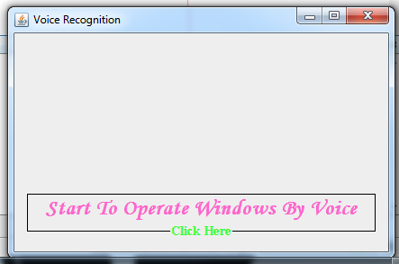

7.2 Configuration Window

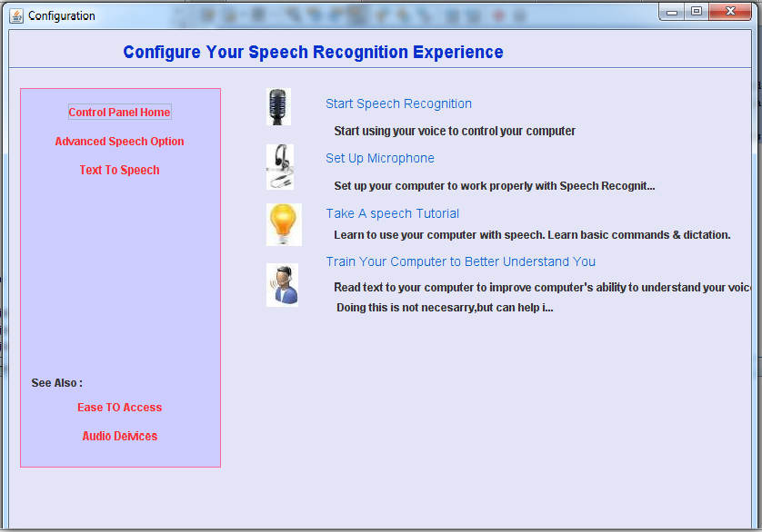

7.3 Device Selection
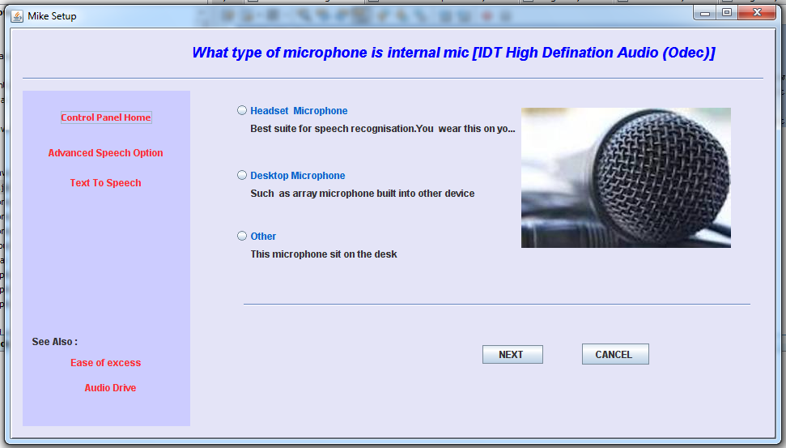
7.4 Microphone Setup
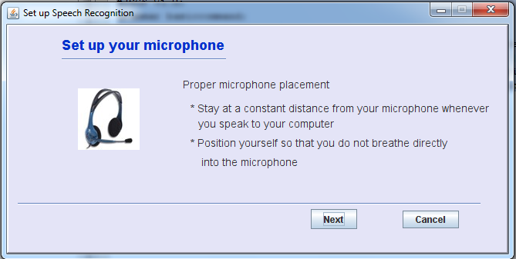

7.5 Setup headphone
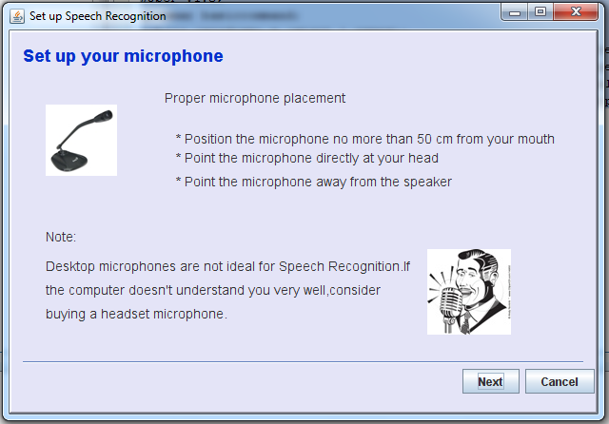

7.6 Recognition setup by microphone
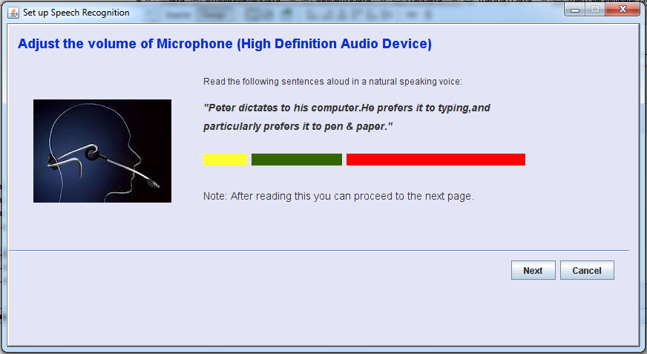

7.7 Recognition Setup of Mike

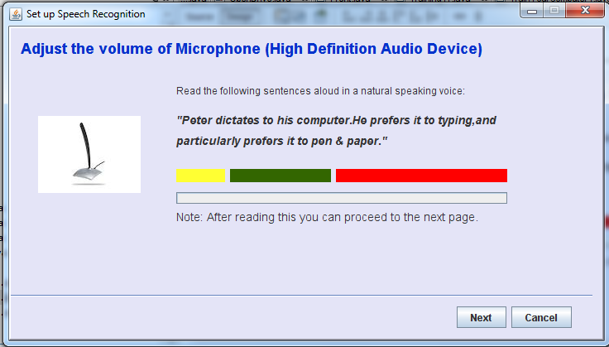
8. CONCLUSION AND FURTHER WORK

This research has successfully achieved the objectives of this study, furthermore, this application provide the great service and useful for computer applications, which aims at representing windows operating system commands based on speech inputs rather than using traditional means of input (e.g. computer keyboard or mouse). The Java Speech Application Programming Interface (JSAPI) will allow applications and applets to use speech technology for the development of advanced user interfaces, it’s easy to use and maintain. With the Java Speech API, developers will be able to develop applications with dynamic and compelling user interfaces. It recommended that future study should include all commands of (MS Windows) and solve some error that found in speech inputs because the noise that happened outside the computer or incorrect pronunciation for some commands, this is one of difficulties that face the researcher during achieving this application. This application with some added features can be the future of the computing system.
9. REFERENCES

[1] Sonam Kumari , Kavita Arya, Komal Saxena, “Controlling of device through speech recognition”paper , March2012.
[2] Anupam Choudhary, Ravi KshirsagarS.,“Process Speech Recognition System using Artificial Intelligence Technique”, paper, Nov. 2012.
[3] Sandeep Kaur, “Mouse Movement using Speech and Non-Speech Characteristics of Human Voice”, international journal, JUNE2012.
[4] Michael S. Fulkerson and Alan W. Biermann, “Javax: A Toolkit for Building Speech-Enabled Applications”, Department of Computer Science, Duke University.
[5] Sun Microsystems, Inc. Business, “Java™ Speech API Programmer’s Guide”, Version1.0 October 26, 1998.
[6] Information about JSAPI. Available: http://java.sun.com/products/java-media/speech.
[7] Bharat Singhvi, Vishnu Kanth T “ADAPTIVE VOICE RESPONSE SYSTEM”, Nov2010. [11] Meeras Salman, “EXECUTING COMMANDS OF OPERATING SYSTEM BY USING SPEECH RECOGNITION SYSTEM: AN EXPERIMENT WITH MICROSOFT WINDOWS”, journal of Kerbala university, 2012.

